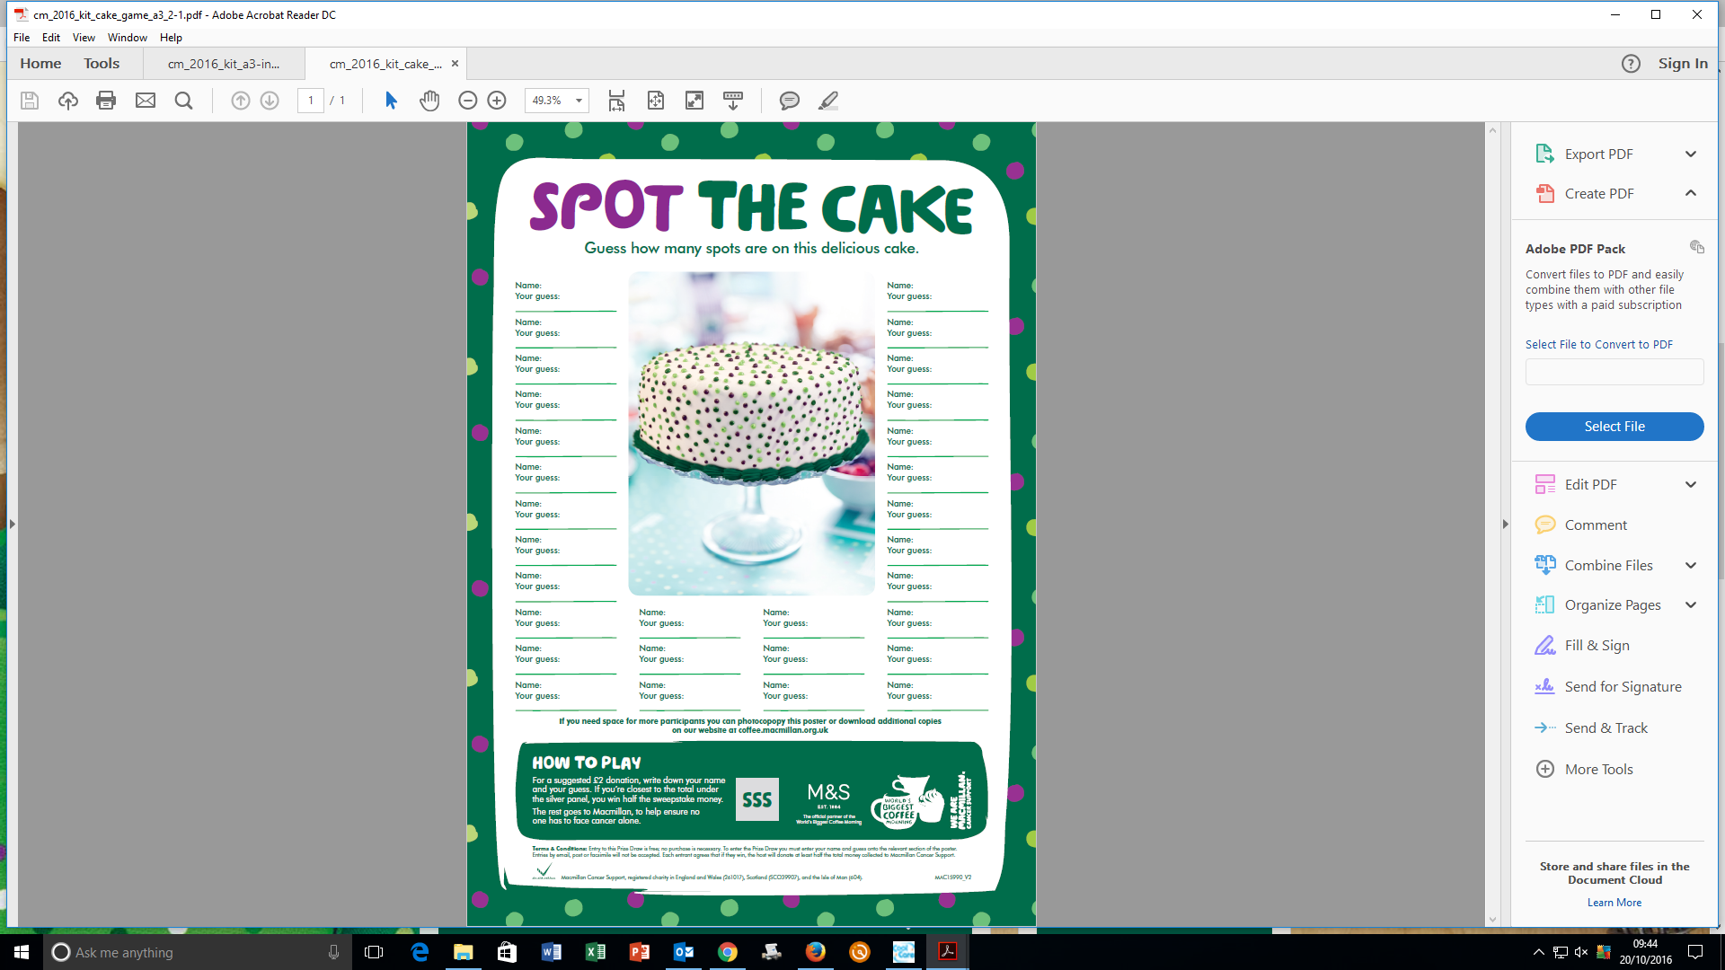**And the winner was……**

**495**

***The number of spots on the cake was 495. This was won by Adriana,***

***our Registered Manager who donated all of the winnings back to Macmillan!!***