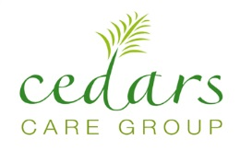
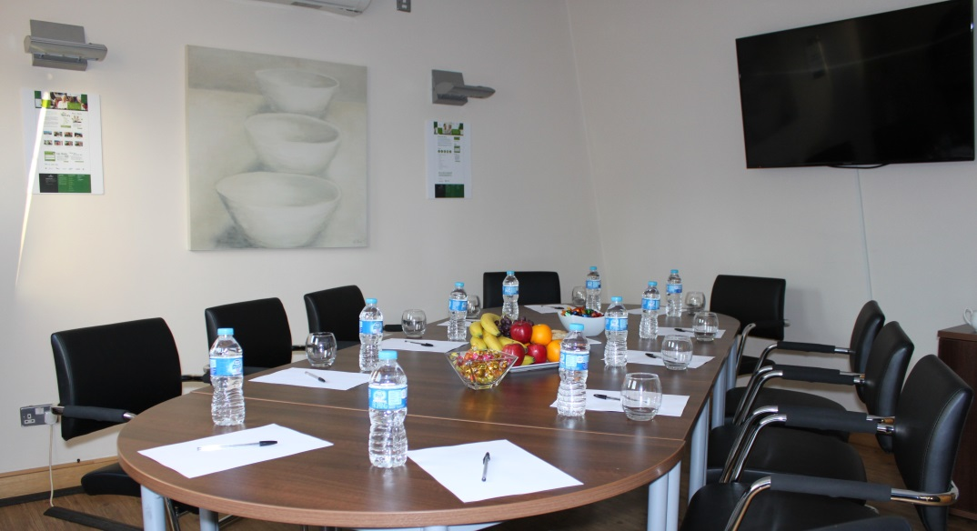
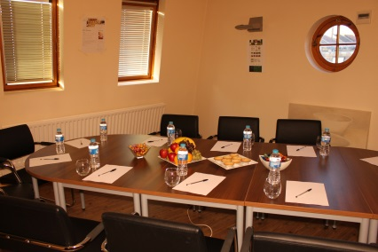

Delegate Package

Book Now
5 to 10 Delegates Maximum

Full day £35.00 per person Includes VAT per person.
- Room Hire 9am – 5:00pm
- Selection of Teas, Coffees & Breakfast Croissants and Danish pastries on arrival
- Mid Morning Teas, Coffees & Biscuits
- Mixed Sandwiches
- Afternoon Teas, Coffees & Biscuits
- Mineral Water & Mints
- Complimentary Wi-Fi
- Pad & Pens/pencil
- 42`inch HD TV Screen
- On-site Conference Manager.

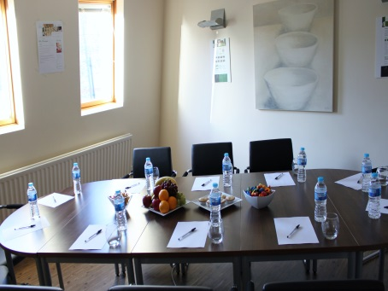
Cedars Care Group
Teyaz House
2b Manor Road
Beckenham
BR3 5LE
Tel: 020 3818 8700

Executive Hour Delegate Package “Gold”

