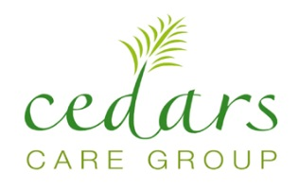
Standard Hour Delegate Package “Gold”
(5 to 10 delegates maxim)
Full day £35.00 per person inc VAT per person
Includes:
- Room Hire 9am – 5:00pm
- Selection of Teas, Coffees & Breakfast croissants and Danish pastries on arrival
- Mid Morning Teas, Coffees & Biscuits
- Mix Sandwiches
- Afternoon Teas, Coffees & Biscuits
- Mineral Water & Mints
- Complimentary Wi-Fi
- Pad & Pens/pencil
- HD TV Screen 42inch
- On-site Conference manager.

Items | Total cost per person
Tea Coffee | £0.90
Sandwiches | £3.60 | 18£ for 5 persons
Water | £0.16 | 2£ for 12 bottles
Biscuits | £0.25 | £1 pack
Danish | £0.45 | 0.45 each
Croissant | £0.50 | £ 1.50 x 6
Total | £5.86
Executive Hour Delegate Package “Silver”
(6 to 10 delegates)
From £25 per person inc VAT per person
Includes:
- Room Hire 9am –12:30pm OR 1:00 pm till 5.30
- Selection of Teas, Coffees & croissants on arrival
- Mid Morning Teas, Coffees & Biscuits
- Afternoon Teas, Coffees Biscuits and Danish pastries
- Mineral Water & Mints
- Complimentary Wi-Fi
- Pad & Pens/pencil
- LED Screen 42inch
- On-site Conference manager.

TWO Standard Hour Delegate Package “Bronze”
(2 to 4 delegates)
From £25.00 Per Hour inc VAT per person
Includes:
- Coffee & Tea Making facilities
- Mineral Water & Mints
- Complimentary Wi-Fi
- Pad & Pens/pencil
- LED 42` TV Screen
- On-site Conference manager

