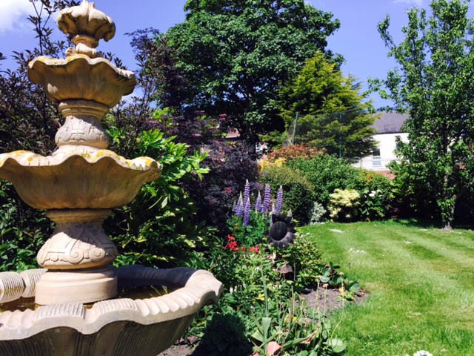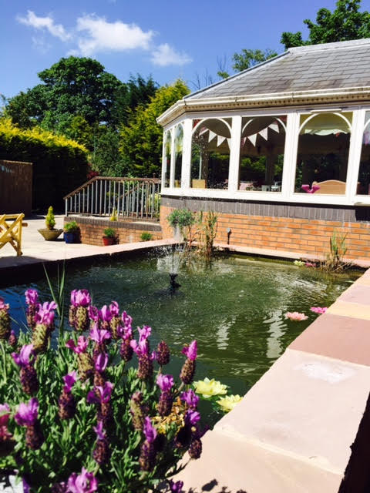

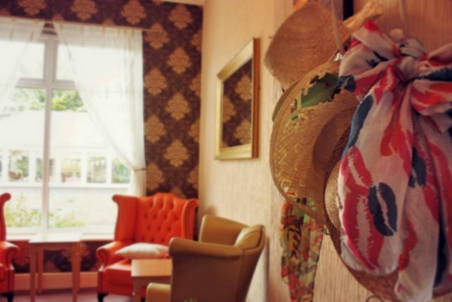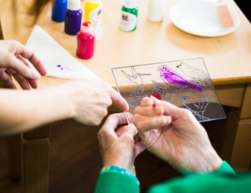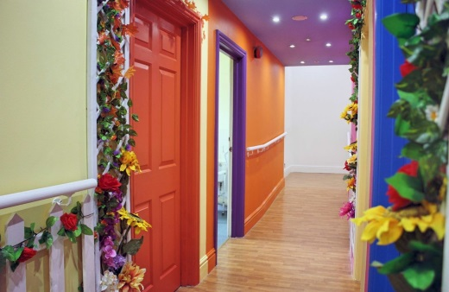

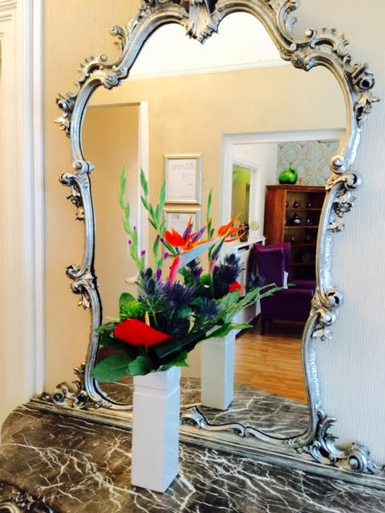



**Cedar Grange**

Providing high quality residential and nursing care for older people with dementia

* Accommodates up to 34 residents in elegant, individually appointed bedrooms - providing short term respite and long term care
* Caring for individuals who need a little extra help or nursing as they get older and suffer from age related illnesses such as short-term memory loss, dementia or Alzheimer’s
* We provide high quality care promoting individual choice, privacy and comfort in an elegant, stimulating, homely environment
* Highly trained clinical & dementia care staff attending to every need 24 hours a day
* Single and double bedrooms available

varied and interesting daily activities for our residents to promote wellbeing and purpose.

Each resident has a life book drawn up when they come into the home so we are aware of any existing hobbies they may have or perhaps introduce them to something new.

We believe that everyone has their own story to tell and therefore make it our business to get to know about the people we care for by spending time getting to know each individual, what interests them and to talk about the things they have achieved in their lives - the good old days!

The involvement and visits from families and friends is vital to the quality of life and wellbeing of our residents, so we aim at providing an environment where both residents and visitors will enjoy a comfortable and enjoyable setting with the option of privacy. Our planned activities and events are key opportunities for family participation and support.

Cedar Grange is a home in the true sense of the word; warm, comfortable and welcoming. We pride ourselves on the quality of the care and surroundings we provide, and on our attention to detail – it’s the little things that matter. We have arranged our home to make it interesting, varied, surprising and stimulating. Cedar Grange has many original features you would expect from properties built around the 1900’s, and mixes these with an exciting and progressive specialist dementia environment.

The communal areas of the home are themed; allowing our residents to relax with others and join in various activities, where dedicated staff are on hand to assist with their individual needs. We have a music room where musicals from the 40s, 50s & 60s can be heard, as well as artists such as Frank Sinatra, Bing Crosby, Dame Vera Lynne and many more. There is also a light and airy garden room and family room. At Cedar Grange we know the importance of providing

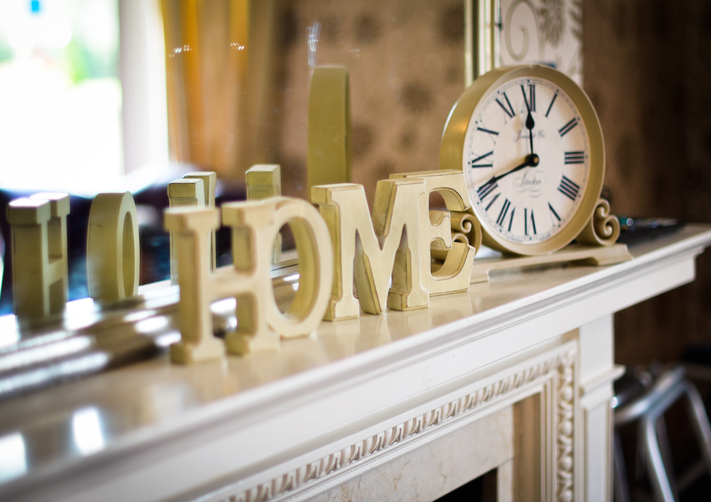

Our 34 bedrooms are all attractively decorated to a high standard, some with en-suite. We feel it is important to give each resident a space to call their own. Therefore we encourage everyone to personalise their rooms by bringing in some of their own small belongings and photograph’s, creating a real home from home. Familiarity and reminiscence is so important to us. This can also ease the transition into care and ensure that every individual’s surrounding is as familiar as possible.

At Cedar Grange, we treat every resident as an individual. For this reason, we offer several types of stay depending on the level of support required; from long term daily nursing care, respite, residential, convalescent, post-operative care, and terminally-ill care. We care for each resident in accordance with their individual care plan under the supervision of a dedicated home manager.

Meals are an important part of the day, and our chef creates a wide range of balanced, nutritious dishes prepared daily, taking into consideration residents’ dietary requirements. Each day varied menu options are provided, allowing a choice of seasonally hot and cold dishes. Popular choices are roast dinners, fish and chips and traditional puddings. Special requests for dishes can be made and alternative options are always available. Meals can be taken in the light and airy dining room or served in the resident’s room if they prefer.

We want our residents to feel very much at home and take care to create comfortable, homely surroundings. We actively seek feedback to ensure that we offer a high quality service and tailor our support and care to the needs of the individual.

**Cedar Grange** summary

**Number of rooms** 34

**Levels of care** Nursing, residential, convalescent, post-operative and terminally-ill

**Staff training** Staff are trained to various levels of qualifications and include Registered General Nursing and National Vocational Qualification’s. All staff are trained in Moving and Handling, infection control, Health & Safety, food hygiene, first aid and attend specialist dementia courses.

**Services available** Parking, laundry, hairdressing, chiropody, occupational therapy, telephone, newspapers *   
\**some services maybe charged separately*



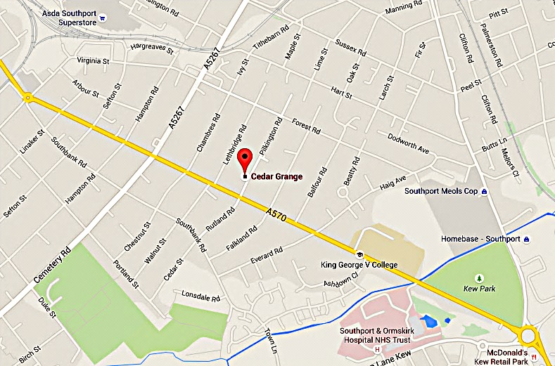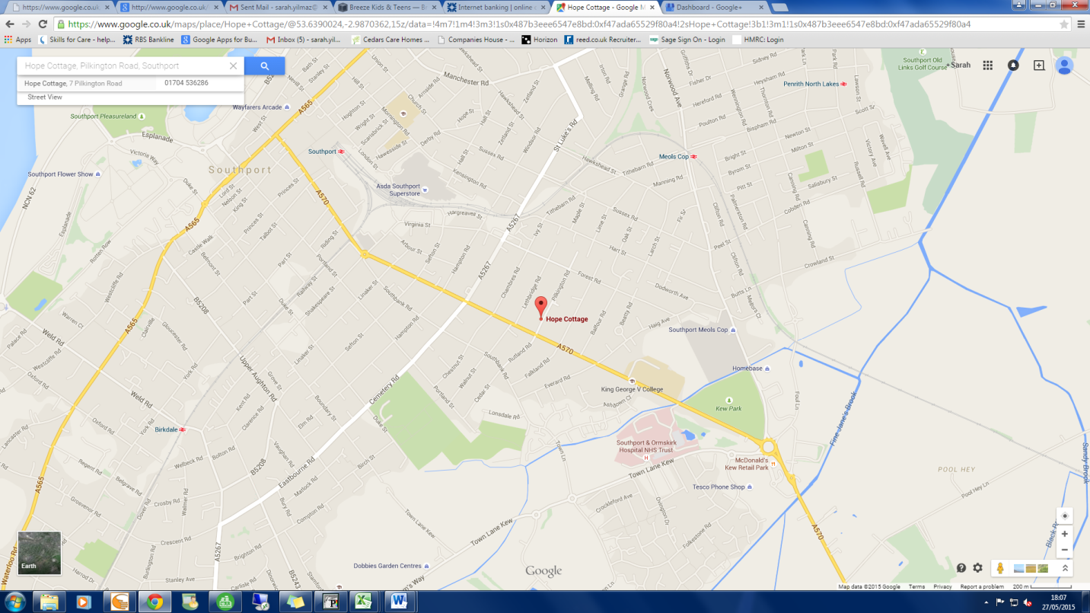

1-7 Pilkington Road

Southport

Merseyside PR8 6PD

Telephone: 01704 536286

Facsimile: 01704 543222

Email: cedargrange@cedarscaregroup.co.uk

www.cedarscaregroup.co.uk